A-Level Psychology Bridging work

Welcome to the Psychology department.
The majority of you will not have studied psychology before. It’s a fascinating subject which impacts every part of our lives. This booklet aims to give you an introduction that will let you see the kind of topics that psychologists study and some of the techniques they use. I hope it gives you a taste for all the excitement and interesting topics to come in your Psychology A-Level!
You are expected to complete all of this booklet. Please add yourself to the Year 11 Google Classroom where you will be able to easy access the links that have been provided. You can also type the work if you prefer (although hand written is just fine)
Specification link:
Edexcel specification
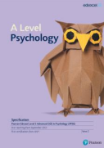
Contact:
Mrs O’Keeffe
s.okeeffe@bishopwalsh.net
https://qualifications.pearson.com/en/qualifications/edexcel-a-levels/psychology-2015.html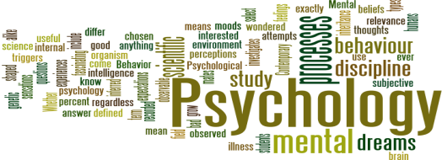
What will you study?
Paper 1
Foundations in
Psychology
4 areas
Social
Cognitive
Biological
Learning
One exam
2 hours
35% of
qualification
Paper 2
Applications of
Psychology
Two areas
Clinical
Psychology
Criminological
One exam
2 hours
35% of
qualification
Paper 3
Psychological Skills Three areas
Methods
Synoptic
review of
studies
Issues and
debates
One exam
2 hours
30% of
qualification
Psychology bridging work Google Classroom

Please add yourself to the Year 11 to 12 Google Classroom
Code: g5ftvqk

Recommended resources
Things to read
Below is the link to a number of magazine articles which looks at recent research on all topic areas in psychology.
https://www.hoddereducation.co.uk/magazines/magazines-extras/psychology-review-extras
The Psychopathy Test by Jon Ronson. Jon Ronson is a journalist who investigates the nature of a psychopath. He questions the validity of testing them and suggests there may be many psychopaths in society who are functioning and non-criminal.
Opening Skinner’s Box by Lauren Slater. Brilliant short summaries of some of the most famous psychological studies. Some of which we study in our course.
Things to watch
Three Identical Strangers Available on 4OD and Netflix. A documentary based on Triplets who were separated at birth. Relates to the nature nurture debate.
The Stanford prison experiment A film
depicting the famous prison study that we’ll learn about in our first topic in social psychology. The Experiment A film depicting the famous psychologist Stanley Milgram that we’ll learn about in our first topic in social psychology. One flew over the cuckoo’s nest Useful for
psychopathology and definitions of abnormality. Beautiful mind Useful for psychopathology and schizophrenia topics.
https://www.bbc.co.uk/iplayer/episode/p082bxzn/stacey dooley-on-the-psych-ward
Zimbardo Ted Talk
https://www.ted.com/talks/philip_zimbardo_the_psychology _of_evil?language=en Great to get you thinking about “what is evil?” for our social psychology topic.
Introduction to Psychology You tube videos: https://www.youtube.com/watch?v=vo4pMVb0R6M&list=PLNo419 yvwUDDuGEekLWgdlJPUA3WOV
Things to listen to
BBC4s “I hear voices” BBC Sounds – ‘I hear voices’ about a woman’s experience of schizophrenia
https://www.bbc.co.uk/programmes/p05q 82d8
BBC4s All in the mind series All in the mind – the impact of psychological research on our lives
https://www.bbc.co.uk/programmes/b03h vx74 BBC4s All in the mind series All in the mind - how attitudes to mental health have changed over the last 25 years
Tasks to complete
Task 1 What is psychology?
Ask three people have not studied psychology what psychology is? Record their responses _______________________________________________________________________________________ _______________________________________________________________________________________ _______________________________________________________________________________________ _______________________________________________________________________________________ _______________________________________________________________________________________ _______________________________________________________________________________________ _______________________________________________________________________________________ _______________________________________________________________________________________ _______________________________________________________________________________________ _______________________________________________________________________________________ _______________________________________________________________________________________ _______________________________________________________________________________________ _______________________________________________________________________________________ _______________________________________________________________________________________ _______________________________________________________________________________________
Using the links below provide a detailed answer to what the study of psychology involves? https://www.bps.org.uk/public/what-is-psychology
Research the following careers in psychology summarising each one in around 150 words
● Clinical psychologist
● Forensic psychologist
● Health psychologist
https://www.careerexplorer.com/careers/forensic-psychologist/
https://www.prospects.ac.uk/job-profiles/clinical-psychologist
https://www.healthcareers.nhs.uk/explore-roles/psychological-therapies/roles/health-psychologist
What does the study of psychology involve?
_______________________________________________________________________________________ _______________________________________________________________________________________ _______________________________________________________________________________________
_______________________________________________________________________________________ _______________________________________________________________________________________ _______________________________________________________________________________________ _______________________________________________________________________________________ _______________________________________________________________________________________ _______________________________________________________________________________________ _______________________________________________________________________________________ _______________________________________________________________________________________ _______________________________________________________________________________________ _______________________________________________________________________________________

Roles of a clinical, forensic and health psychologist?
_______________________________________________________________________________________ _______________________________________________________________________________________ _______________________________________________________________________________________ _______________________________________________________________________________________ _______________________________________________________________________________________ _______________________________________________________________________________________ _______________________________________________________________________________________ _______________________________________________________________________________________ _______________________________________________________________________________________ _______________________________________________________________________________________ _______________________________________________________________________________________ _______________________________________________________________________________________ _______________________________________________________________________________________
Task 2 Introduction to Psychology
Watch the TED talk and choose 3 myths to describe and explain how they have been debunked
https://www.ted.com/talks/ben_ambridge_10_myths_about_psychology_debunked/transcript?language= en#t-388796
_______________________________________________________________________________________ _______________________________________________________________________________________ _______________________________________________________________________________________ _______________________________________________________________________________________ _______________________________________________________________________________________ _______________________________________________________________________________________
_______________________________________________________________________________________ _______________________________________________________________________________________ _______________________________________________________________________________________ _______________________________________________________________________________________ _______________________________________________________________________________________ _______________________________________________________________________________________ _______________________________________________________________________________________
Task 3 Topics of study
Using the link below research and take notes on 5 different areas that you find interesting https://www.bps.org.uk/public/a-z-of-psychology
_______________________________________________________________________________________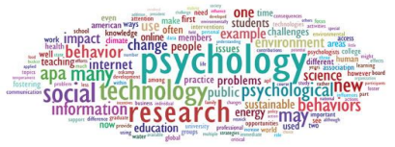 _______________________________________________________________________________________ _______________________________________________________________________________________ _______________________________________________________________________________________ _______________________________________________________________________________________ _______________________________________________________________________________________ _______________________________________________________________________________________ _______________________________________________________________________________________ _______________________________________________________________________________________ _______________________________________________________________________________________ _______________________________________________________________________________________ _______________________________________________________________________________________ _______________________________________________________________________________________
_______________________________________________________________________________________ _______________________________________________________________________________________ _______________________________________________________________________________________ _______________________________________________________________________________________
_______________________________________________________________________________________ _______________________________________________________________________________________ _______________________________________________________________________________________ _______________________________________________________________________________________ _______________________________________________________________________________________ _______________________________________________________________________________________ _______________________________________________________________________________________ _______________________________________________________________________________________ _______________________________________________________________________________________
Task 4 Ethics in Psychology
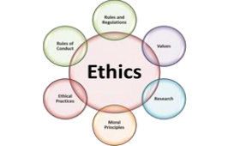
What are ethics and why do we study them in Psychology? In Britain, ethical guidelines for research are published by the British Psychological Society (BPS). The purpose of these codes of conduct is to protect the participants of the research, the reputation of psychology and psychologists themselves. In Psychology you will learn about six different ethical guidelines. These are things that Psychologists should follow when conducting studies.
The six guidelines are as follows:
1. Protection from Harm
2. Right to Withdraw
3. Confidentiality
4. Informed Consent
5. Debriefing
6. Deception
Watch the following video to gain a brief understanding of why ethics are important. There are other resources too. Complete the table defining the 6 ethical guidelines.
https://www.youtube.com/watch?v=kpZHkr9_8Gc
Guideline | Description
Informed consent
Right to withdraw

Confidentiality
Protection from
harm
Debrief
Deception

Task 5 Unethical studies in psychology
Some of the most fascinating and useful studies in psychology are the most unethical. Research 3 unethical studies. Give details about the study and give reasons about why they are unethical?
_______________________________________________________________________________________ _______________________________________________________________________________________ _______________________________________________________________________________________ _______________________________________________________________________________________ _______________________________________________________________________________________ _______________________________________________________________________________________ _______________________________________________________________________________________ _______________________________________________________________________________________ _______________________________________________________________________________________ _______________________________________________________________________________________ _______________________________________________________________________________________
_______________________________________________________________________________________ _______________________________________________________________________________________
Task 6 Studies in psychology
Study: Dr Money, the case of David Reimer. The boy who became a girl.
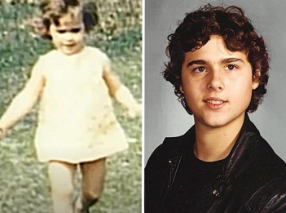
In psychology we look at a range of different studies to investigate behaviours. This study investigates the case of David Reimer. David was born male and given the name Bruce. However, due to a tragic accident David was brought up as a girl. Watch the documentary on this case and answer the questions below.
1. Was his study ethical? Why / why not? Use your knowledge from your task in Activity number 4 to answer this question
2. How does this study support the argument that nurture cannot overturn nature. https://www.youtube.com/watch?v=9LQBcAVghu4&t=279s
_______________________________________________________________________________________ _______________________________________________________________________________________ _______________________________________________________________________________________ _______________________________________________________________________________________ _______________________________________________________________________________________ _______________________________________________________________________________________ _______________________________________________________________________________________ _______________________________________________________________________________________ _______________________________________________________________________________________ _______________________________________________________________________________________ _______________________________________________________________________________________
_______________________________________________________________________________________ _______________________________________________________________________________________
Task 7 Theories in psychology
We will study four different schools of psychology in Year 12. Behaviour is explained differently by psychologists from each approach. For example - are you born with a personality or are personalities a product of our environment
● Social psychology
● Cognitive psychology
● Biological psychology
● Learning Theories/Behaviour Approach
Cognitive psychology
Cognitive psychology involves the study of internal mental processes—all of the things that go on inside your brain, including perception, thinking, memory, attention, language, problem-solving, and learning.
The assumption of cognitive psychology is that the mind operates in a similar way to how a computer processes information. This processing takes place in the form of thoughts, and uses cognitive ‘models’.
There are numerous practical applications for this cognitive research, such as providing help coping with memory disorders, increasing decision-making accuracy, finding ways to help people recover from brain injury, treating learning disorders, and structuring educational curricula to enhance learning.
Learning more about how people think and process information not only helps researchers gain a deeper understanding of how the human brain works, but it allows psychologists to develop new ways of helping people deal with psychological difficulties.
For example, by recognizing that attention is both a selective and limited resource, psychologists are able to come up with solutions that make it easier for people with attentional difficulties to improve their focus and concentration.
Findings from cognitive psychology have also improved our understanding of how people form, store, and recall memories. By knowing more about how these processes work, psychologists can develop new ways of helping people improve their memories and combat potential memory problems.
For example, psychologists have found that while your short-term memory is quite short and limited (lasting just 20 to 30 seconds and capable of holding between five and nine items), rehearsal strategies can improve the chances that information will be transferred to long-term memory, which is much more stable and durable.
The multi-store model of memory
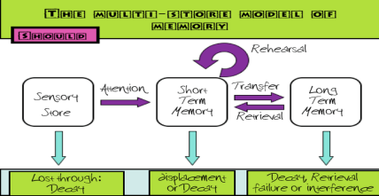
Using this website answer the following questions
https://www.simplypsychology.org/multi-store.html
1. What are the three main stores in the multi-store model of memory?
_______________________________________________________________________________________ _______________________________________________________________________________________ _______________________________________________________________________________________
2. What are the three ways in which we encode information?
_______________________________________________________________________________________ _______________________________________________________________________________________ _______________________________________________________________________________________
3. What is the capacity of STM?
_______________________________________________________________________________________ _______________________________________________________________________________________ _______________________________________________________________________________________
4. What is the duration of STM?
_______________________________________________________________________________________ _______________________________________________________________________________________ _______________________________________________________________________________________
5. Explain two strengths of the multi-store model of memory
___________________________________________________________________________ ___________________________________________________________________________ ___________________________________________________________________________ ___________________________________________________________________________
6. Explain two weaknesses of the multi-store model of memory
___________________________________________________________________________ ___________________________________________________________________________ ___________________________________________________________________________
Memory in the real world
Using the link below, describe why is our memory sometimes unreliable?
https://www.psychologywizard.net/multi-store-model-ao1-ao2-ao3.html
_______________________________________________________________________________________ _______________________________________________________________________________________ _______________________________________________________________________________________ _______________________________________________________________________________________ _______________________________________________________________________________________ _______________________________________________________________________________________ _______________________________________________________________________________________ _______________________________________________________________________________________ _______________________________________________________________________________________
Task 8 Biological psychology
Research the work of biological psychology. What are the areas of study? What behaviours are they interested in? What research methods do they use?
_______________________________________________________________________________________ _______________________________________________________________________________________ _______________________________________________________________________________________ _______________________________________________________________________________________ _______________________________________________________________________________________ _______________________________________________________________________________________ _______________________________________________________________________________________ _______________________________________________________________________________________ _______________________________________________________________________________________
Task 9 Debates in Psychology
In psychology there are lots of debates, one of the biggest and most controversial is whether psychology is a science. Most people assume Psychology is an easy or ‘soft’ subject which cannot possibly be a science. But is it?
It is your job to come to a conclusion as to whether or not Psychology IS a hard science. Research arguments for and against Psychology as a Science and produce a debate on this.
Consider:
1) The Subject Content
2) Research Methods Used
Evidence for psychology is a science | Evidence for psychology not being a science

Task 10 Methodology – Can you handle the data?
Answer the exam questions below
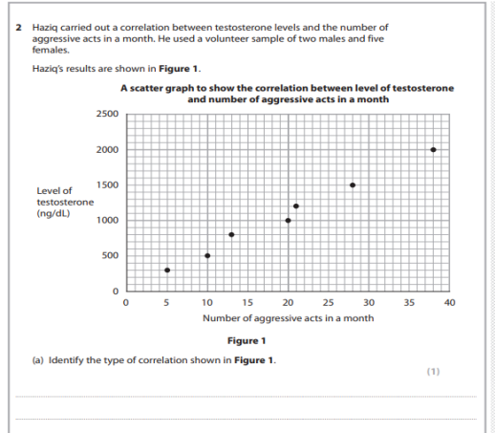
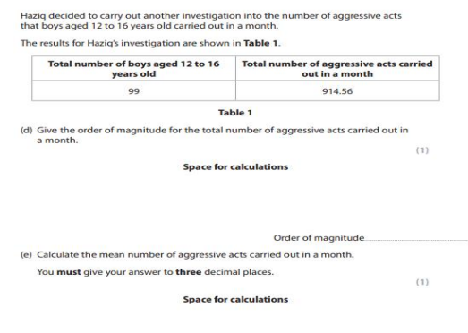z
